**Item 24235B**

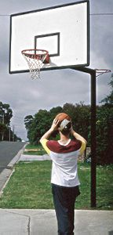Reversible Basketball/Netball Goals Hot Dipped Galvanised 115mm Post 2.4mt Outreach.

Suits Regulation Size Basketball (28mt) Netball (30.5mt) Courts

* with 2.4mt Outreach.
* Suits Regulation Size Basketball Court (28mt)
* Suits Regulation Size Netball Court (30.5mt)
* Backboard 1.80mt x 1.05mt
* 115mm Post Hot Dipped Galvanised
* Ground Sleeve

**Item 24234**

Basketball/Netball Reversible Goals Suitable for Regulation Netball Court (30.5mt & Modified Basketball Court (29.2mt)

* 115mm Heavy Duty
* Rotates 360 Degrees 16mm netball ring at rear.
* Suitable for:
* Regulation Netball Court (30.5mt)
* Modified Basketball Court (29.2mt)

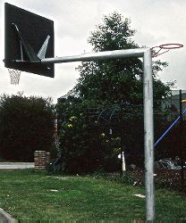

**Item 24228**

* Rotates with 22mm netball ring on rear
* The netball ring is mounted with no protruding upright behind the ring which is regulation
* Lockable, key and turning tool are supplied
* Clearance of 2.8m to 3.6m is required to rotate post
* Ideal for multipurpose court areas and allows posts to be mounted well away from base line